Center Programs:
Insurance Navigation:
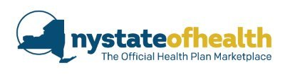
NY State of Health is your place to shop, compare, and enroll in a low-cost, quality health insurance plan that’s right for you. And it’s the only place you can receive financial assistance based on your income, to lower your costs even more. Individuals, families and small businesses can use the Marketplace to help them compare insurance options, calculate costs and select coverage online, in-person, over the phone or by mail. For more information please contact our IPA Navigator, Debbie Martin at 607-778-0849. This program serves Schoharie County.

Medicaid Waiver Services:
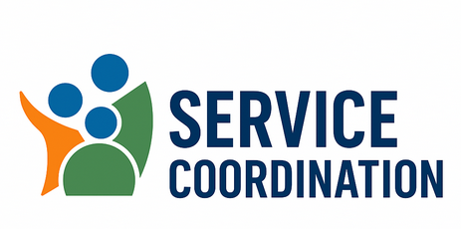
The NHTD (Nursing Home Transition and Diversion) and TBI (Traumatic Brain Injury) waivers are Medicaid programs in New York that allow individuals with disabilities and seniors to receive services in the community instead of a nursing home. These waivers provide a range of services to help people maintain their independence and avoid institutionalization. Reach out to Selena Granata or Jena Parker for more information.

Open Doors Program:
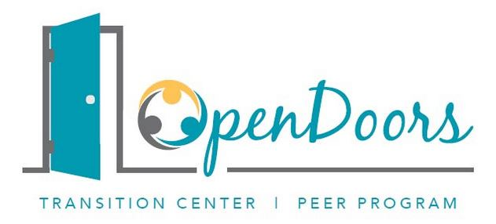
New York Association on Independent Living( NYAIL) is the NYS Open Doors Transition Center, and has transition specialists at ILCs across the state to directly assist people in nursing homes to access the services they need to return to the community. The transition specialists also work with people in ICF/IIDs who are moving to community settings or are transitioning to a model of increased community integration in their current home. Reach out to Shelly Levers, Transition Specialist for more information.

Olmstead Housing Program:

Olmstead Housing Subsidy (OHS) is a rental housing subsidy program that provides supportive housing services and rental subsidies for Medicaid members that are residing in a skilled nursing facility (SNF) and can safely transition to the community. The funding was made available as part of the Medicaid Redesign Team’s Supportive Housing Workgroup initiative to help address the needs of eligible Medicaid participants in transitioning from Skilled Nursing Facility settings.

Rapid Transition Housing:
The Rapid Transition Housing Program (RTHP) provides a rental subsidy and supportive housing services for vulnerable high-need Medicaid members using a housing first model. RTHP, previously known as Nursing Home to Independent Living (NHIL), is a Medicaid Redesign Team initiative funded by the Department of Health and administered by the New York Association on Independent Living. The program started in four areas of the state: Long Island, Syracuse, New York City and Rochester. The program is currently expanding to cover all of New York State.
Eligible individuals with one or more documented chronic physical disabilities or have two or more chronic conditions (). Participants in the program must be on Medicaid and referred as homeless *high-utilizers.

Architectural Barrier Services:
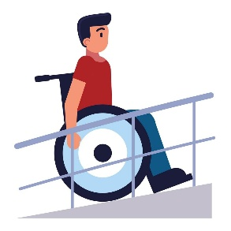
Our Architectural Barrier Services offer professional assessments to help identify and remove accessibility challenges in your home, school, business, or public facility. We provide: On-site evaluations to assess physical barriers, Personalized guidance on removing or modifying accessibility obstacles, Referrals to trusted resources and contractors for home modifications, Support for homeowners, schools, business owners, and government agencies. Whether you're looking to improve safety and accessibility at home or ensure compliance in public spaces, we’re here to help. Please contact Don Wyckoff to schedule an on-site.

ACES:
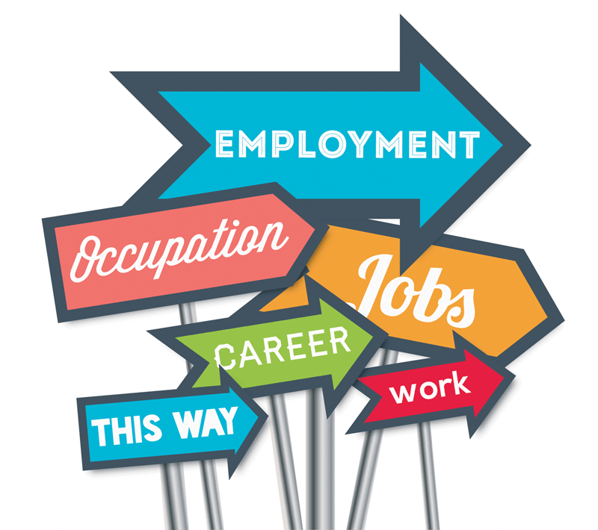
Our Assisted Competitive Employment program helps adults with mental health support needs pursue meaningful, long-term employment in their community. Participants receive personalized assistance with: Building resumes and completing job applications, Navigating benefits and understanding how employment may impact them, Practicing interview skills and developing workplace confidence and Accessing ongoing mental health support throughout the employment journey. This program is offered strictly in Schoharie County. To schedule an appointment or for more information contact Joda Kearney or Maria Savino. We are committed to helping individuals achieve greater independence and career success.

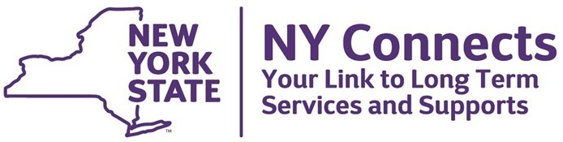
NY Connects:

NY Connects is here to help individuals with disabilities—and their families, friends, and caregivers—find the information and support they need to live independently and thrive within their communities. We provide guidance on a variety of essential services, including: Independent Living Resources, Employment Opportutnities, and assistance with applications, such as SNAP, HEAP, and Social Security Benefits. As your one-stop access point for community based supports NY Connects makes it easier to navigate the services available tot you. Appointments are flexible and we serve Delaware, Otsego, & Schoharie Counties. For more information contact Vince Baker at the Center.
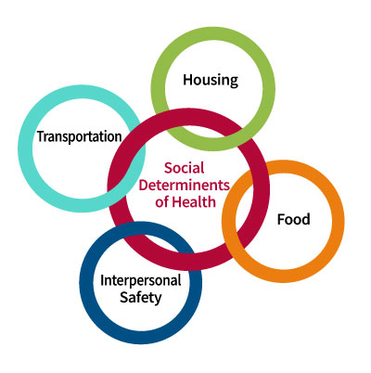
Social Care Network:
Social Care Network supports the Medicaid population by delivering Health-Related Social Needs services. If the Medicaid Member meets certain eligibility criteria they may receive services for nutrition, housing, transportation, and social care management. Please reach out to Heather Merrill or Pam Butler to schedule a screening for eligibility. SCN serves Schoharie, Delaware and Otsego Counties.

Lending Closet:
Our Lending Closet offers free durable medical equipment to community members in need. This program supports individuals with temporary or long-term mobility and health needs. Available items include (but are not limited to): Shower chairs & benches, Wheelchairs, Walkers & rollators, Lift chairs & Hoyer lifts, Hospital beds, commodes, and Adult incontinence briefs. Please note: All equipment is donation-based, so availability may vary and is not guaranteed. To check availability please contact Shelly Levers or Don Wyckoff, or visit the Center, Monday, Wednesday, or Friday 8:00 am – 4:00 pm.
